Spring Boot with ReactJS Integration and Backend CURD Operation

Aim: Spring Boot with ReactJS Integration and Backend CURD Operation

Prerequisites:
Implementation skill in Reactjs
Implementation skill in Spring Boot Application with JPA and Database

Description:
Implement the necessary ReactJS front end pages for sending the request and receive responses from the back end (spring boot app) designed as per the below requirements. Develop a Spring Boot web application to manage a list of products in a warehouse. The application should handle CRUD operations to manage product details such as Product ID, Name, Description, Price, and Quantity. The application should include features to add new products, display a list of all products, update existing product details, and delete products from the database. Use Spring Web MVC for handling HTTP requests, Spring Data JPA for database interactions. Ensure the application is configured to connect to a MySQL/PostgreSQL database and implement both setter-based or constructor-based dependency injections to manage service and repository layers effectively.

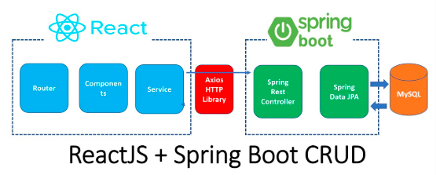

Integrating a ReactJS frontend with a Spring Boot backend using the Model-View-Controller (MVC) architecture facilitates a structured approach to developing a warehouse management system that performs CRUD operations on product data. In this setup, ReactJS serves as the View, providing a dynamic user interface that interacts with users. The Controller, implemented in Spring Boot, processes incoming HTTP requests, manages business logic, and coordinates responses between the View and the Model. Spring Data JPA acts as the Model, handling data persistence and retrieval from a MySQL or PostgreSQL database. This separation of concerns enhances maintainability and scalability, allowing each component to be developed and tested independently.
To establish effective communication between the ReactJS frontend and the Spring Boot backend, RESTful APIs are utilized. The ReactJS application employs Axios to send HTTP requests to these endpoints, enabling operations such as adding, updating, and deleting product records. Spring Boot's controller classes, annotated with @RestController, handle these requests and interact with the service layer, which contains the business logic. The service layer, in turn, communicates with the repository layer, where Spring Data JPA manages database interactions. This layered architecture ensures that each component has a distinct responsibility, promoting clean code practices and facilitating easier debugging and testing. Additionally, implementing either setter-based or constructor-based dependency injection within the service and repository layers allows for flexible and efficient management of dependencies, further enhancing the application's modularity and testability.

Creating reactjs Project:

Create one empty folder with name week9p
And press in location path i.e cmd and you will get below path

- D:\FSAD\week9p>
- D:\FSAD\week9p> code .
- Click on terminal and create project as shown below
- D:\FSAD\week9p> npm create vite@latest week9p
- D:\FSAD\week9p> cd week9p
- D:\FSAD\week9p> npm install
- D:\FSAD\week9p> npm install axios
- D:\FSAD\week9p> npm install axios react-router-dom

Frontend(reactJS):

Project structure:

Week9p
│── src/
│ ├── components/
│ │ ├── ProductList.jsx
│ │ ├── AddProduct.jsx
│ │ ├── UpdateProduct.jsx
│ │ ├── DeleteProduct.jsx
│ ├── services/
│ │ ├── productService.jsx
│ ├── App.jsx

ProductList.jsx

import React, { useEffect, useState } from 'react';
import { getAllProducts, deleteProduct } from '../services/productService';

const ProductList = () => {
const [products, setProducts] = useState([]);

useEffect(() => {
getAllProducts().then(response => {
setProducts(response.data);
});
}, []);

const handleDelete = (id) => {
deleteProduct(id).then(() => {
setProducts(products.filter(product => product.id !== id));
});
};

return (
<div>
<h2>Product List</h2>
<ul>
{products.map(product => (
<li key={product.id}>
{product.name} - ${product.price}
<button onClick={() => handleDelete(product.id)}>Delete</button>
</li>
))}
</ul>
</div>
);
};

export default ProductList;

AddProduct.jsx

import React, { useState } from 'react';
import { addProduct } from '../services/productService';

const AddProduct = () => {
const [product, setProduct] = useState({ name: '', description: '', price: '', quantity: '' });

const handleChange = (e) => {
setProduct({ ...product, [e.target.name]: e.target.value });
};

const handleSubmit = (e) => {
e.preventDefault();
addProduct(product).then(() => {
alert("Product added successfully!");
});
};

return (
<form onSubmit={handleSubmit}>
<input type="text" name="name" placeholder="Name" onChange={handleChange} required />
<input type="text" name="description" placeholder="Description" onChange={handleChange} />
<input type="number" name="price" placeholder="Price" onChange={handleChange} required />
<input type="number" name="quantity" placeholder="Quantity" onChange={handleChange} required />
<button type="submit">Add Product</button>
</form>
);
};

export default AddProduct;

UpdateProduct.jsx

import React, { useState, useEffect } from "react";
import { useParams, useNavigate } from "react-router-dom";
import { updateProduct, getAllProducts } from "../services/productService";

const UpdateProduct = () => {
const { id } = useParams(); // Get product ID from route params
const navigate = useNavigate();
const [product, setProduct] = useState({
name: "",
description: "",
price: 0,
quantity: 0,
});

// Fetch product details when component mounts
useEffect(() => {
getAllProducts().then((response) => {
const productData = response.data.find((p) => p.id.toString() === id);
if (productData) {
setProduct(productData);
}
});
}, [id]);

const handleChange = (e) => {
setProduct({ ...product, [e.target.name]: e.target.value });
};

const handleSubmit = async (e) => {
e.preventDefault();
try {
await updateProduct(id, product);
alert("Product updated successfully!");
navigate("/"); // Redirect to product list
} catch (error) {
console.error("Error updating product:", error);
alert("Failed to update product");
}
};

return (
<div>
<h2>Update Product</h2>
<form onSubmit={handleSubmit}>
<label>Name:</label>
<input type="text" name="name" value={product.name} onChange={handleChange} required />

<label>Description:</label>
<input type="text" name="description" value={product.description} onChange={handleChange} required />

<label>Price:</label>
<input type="number" name="price" value={product.price} onChange={handleChange} required />

<label>Quantity:</label>
<input type="number" name="quantity" value={product.quantity} onChange={handleChange} required />

<button type="submit">Update Product</button>
</form>
</div>
);
};

export default UpdateProduct;

DeleteProduct.jsx

import React from "react";
import { useNavigate, useParams } from "react-router-dom";
import { deleteProduct } from "../services/productService";

const DeleteProduct = () => {
const { id } = useParams(); // Get product ID from URL params
const navigate = useNavigate();

const handleDelete = async () => {
try {
await deleteProduct(id);
alert("Product deleted successfully!");
navigate("/"); // Redirect to product list
} catch (error) {
console.error("Error deleting product:", error);
alert("Failed to delete product");
}
};

return (
<div>
<h2>Are you sure you want to delete this product?</h2>
<button onClick={handleDelete}>Yes, Delete</button>
<button onClick={() => navigate("/")}>Cancel</button>
</div>
);
};

export default DeleteProduct;

productService.jsx

import axios from 'axios';

const API_URL = "http://localhost:7777/api/products";

export const getAllProducts = () => axios.get(API_URL);
export const addProduct = (product) => axios.post(API_URL, product);
export const updateProduct = (id, product) => axios.put(`${API_URL}/${id}`, product);
export const deleteProduct = (id) => axios.delete(`${API_URL}/${id}`);

App.jsx:

import React from "react";
import { BrowserRouter as Router, Routes, Route } from "react-router-dom";
import ProductList from "./components/ProductList";
import AddProduct from "./components/AddProduct";
import UpdateProduct from "./components/UpdateProduct";
import DeleteProduct from "./components/DeleteProduct";

const App = () => {
return (
<Router>
<Routes>
<Route path="/" element={<ProductList />} />
<Route path="/add" element={<AddProduct />} />
<Route path="/update/:id" element={<UpdateProduct />} />
<Route path="/delete/:id" element={<DeleteProduct />} />
</Routes>
</Router>
);
};

export default App;

Backend(SpringBoot)
Creating Project Structure:
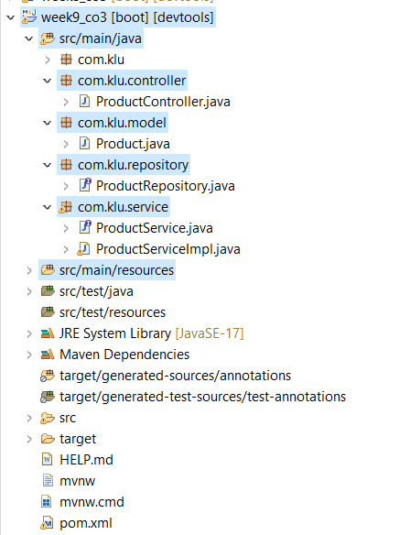

ProductController.java
package com.klu.controller;

import com.klu.model.Product;
import com.klu.service.ProductService;
import org.springframework.web.bind.annotation.*;

import java.util.List;

@RestController
@RequestMapping("/api/products")
@CrossOrigin(origins = "http://localhost:5173")
public class ProductController {

private final ProductService productService;

public ProductController(ProductService productService) {
this.productService = productService;
}

@GetMapping
public List<Product> getAllProducts() {
return productService.getAllProducts();
}

@GetMapping("/{id}")
public Product getProductById(@PathVariable Long id) {
return productService.getProductById(id);
}

@PostMapping
public Product addProduct(@RequestBody Product product) {
return productService.saveProduct(product);
}

@PutMapping("/{id}")
public Product updateProduct(@PathVariable Long id, @RequestBody Product product) {
return productService.updateProduct(id, product);
}

@DeleteMapping("/{id}")
public void deleteProduct(@PathVariable Long id) {
productService.deleteProduct(id);
}
}

Product.java

package com.klu.model;

import jakarta.persistence.*;
import lombok.*;

@Entity
@Table(name = "products")
@Getter
@Setter
@NoArgsConstructor
@AllArgsConstructor
public class Product {
@Id
@GeneratedValue(strategy = GenerationType.IDENTITY)
private Long id;

private String name;
private String description;
private double price;
private int quantity;
}

ProductRepository.java
package com.klu.repository;

import org.springframework.data.jpa.repository.JpaRepository;
import org.springframework.stereotype.Repository;

import com.klu.model.Product;

@Repository
public interface ProductRepository extends JpaRepository<Product, Long> { }

ProductService.java
package com.klu.service;

import com.klu.model.Product;
import java.util.List;

public interface ProductService {
List<Product> getAllProducts();
Product getProductById(Long id);
Product saveProduct(Product product);
Product updateProduct(Long id, Product product); // This should return an updated Product
void deleteProduct(Long id); // Follow consistent parameter naming
}

ProductServiceImpl.java
package com.klu.service;

import java.util.List;

import org.springframework.beans.factory.annotation.Autowired;
import org.springframework.stereotype.Service;

import com.klu.model.Product;
import com.klu.repository.ProductRepository;

@Service
public class ProductServiceImpl implements ProductService {

private final ProductRepository productRepository;

@Autowired
public ProductServiceImpl(ProductRepository productRepository) {
this.productRepository = productRepository;
}

@Override
public List<Product> getAllProducts() {
return productRepository.findAll();
}

@Override
public Product getProductById(Long id) {
return productRepository.findById(id).orElse(null);
}

@Override
public Product saveProduct(Product product) {
return productRepository.save(product);
}

@Override
public Product updateProduct(Long id, Product product) {
if (productRepository.existsById(id)) {
product.setId(id);
return productRepository.save(product);
}
return null;
}

@Override
public void deleteProduct(Long id) {
productRepository.deleteById(id);
}
}

application . properties:

spring.application.name=week9_co3
spring.datasource.url=jdbc:mysql://localhost:3306/kluh
spring.datasource.username=root
spring.datasource.password=root
spring.datasource.driver-class-name=com.mysql.cj.jdbc.Driver
spring.jpa.database-platform=org.hibernate.dialect.MySQL8Dialect
spring.jpa.hibernate.ddl-auto=update
spring.jpa.show-sql=true
logging.level.org.springframework=DEBUG
logging.level.org.hibernate=DEBUG
server.port=7777

pom.xml:

<?xml version="1.0" encoding="UTF-8"?>
<project xmlns="http://maven.apache.org/POM/4.0.0" xmlns:xsi="http://www.w3.org/2001/XMLSchema-instance"
xsi:schemaLocation="http://maven.apache.org/POM/4.0.0 https://maven.apache.org/xsd/maven-4.0.0.xsd">
<modelVersion>4.0.0</modelVersion>
<parent>
<groupId>org.springframework.boot</groupId>
<artifactId>spring-boot-starter-parent</artifactId>
<version>3.4.3</version>
<relativePath/> <!-- lookup parent from repository -->
</parent>
<groupId>com.klu</groupId>
<artifactId>week9_co3</artifactId>
<version>0.0.1-SNAPSHOT</version>
<name>week9_co3</name>
<description>Demo project for Spring Boot</description>
<url/>
<licenses>
<license/>
</licenses>
<developers>
<developer/>
</developers>
<scm>
<connection/>
<developerConnection/>
<tag/>
<url/>
</scm>
<properties>
<java.version>17</java.version>
</properties>
<dependencies>
<dependency>
<groupId>org.springframework.boot</groupId>
<artifactId>spring-boot-starter-data-jpa</artifactId>
</dependency>
<dependency>
<groupId>org.springframework.boot</groupId>
<artifactId>spring-boot-starter-web</artifactId>
</dependency>

<dependency>
<groupId>org.springframework.boot</groupId>
<artifactId>spring-boot-devtools</artifactId>
<scope>runtime</scope>
<optional>true</optional>
</dependency>
<dependency>
<groupId>com.mysql</groupId>
<artifactId>mysql-connector-j</artifactId>
<scope>runtime</scope>
</dependency>

<dependency>
<groupId>org.projectlombok</groupId>
<artifactId>lombok</artifactId>
<version>1.18.30</version> <!-- Use the latest version -->
<scope>provided</scope>
</dependency>
<dependency>
<groupId>org.springframework.boot</groupId>
<artifactId>spring-boot-starter-test</artifactId>
<scope>test</scope>
</dependency>
<dependency>
<groupId>com.klu</groupId>
<artifactId>2-BasicSpringApplication</artifactId>
<version>0.0.1-SNAPSHOT</version>
</dependency>
</dependencies>

<build>
<plugins>
<plugin>
<groupId>org.springframework.boot</groupId>
<artifactId>spring-boot-maven-plugin</artifactId>
</plugin>
</plugins>
</build>

</project>

Database Schema & Queries (MySQL)

Create Database
CREATE DATABASE kluh;

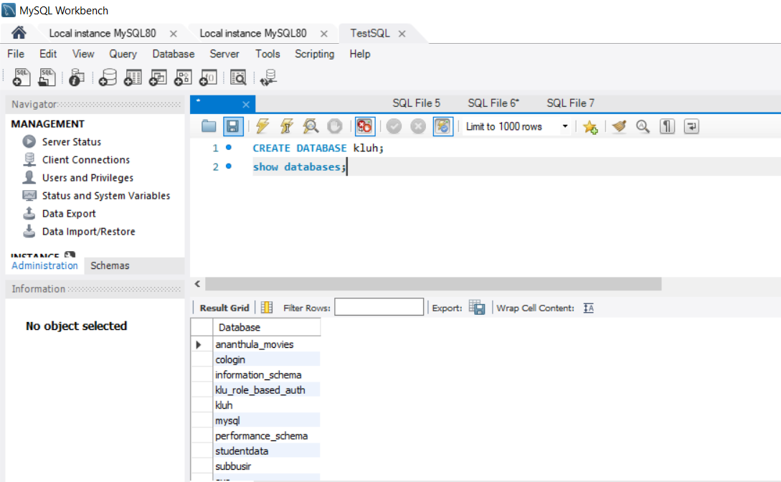
Use Database
USE kluh;

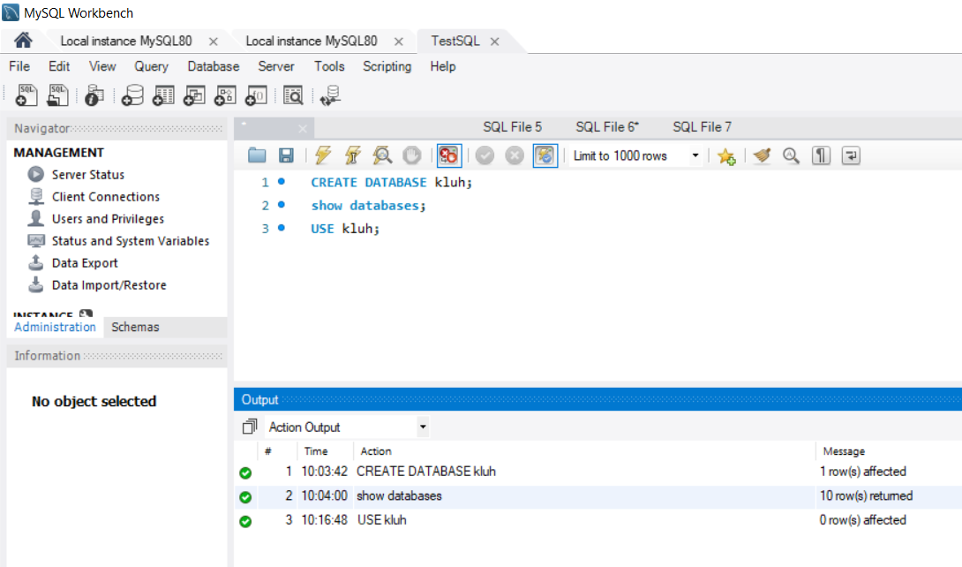

Create Table
CREATE TABLE products (
id INT AUTO_INCREMENT PRIMARY KEY,
name VARCHAR(255) NOT NULL,
description TEXT,
price DECIMAL(10,2) NOT NULL,
quantity INT NOT NULL
);

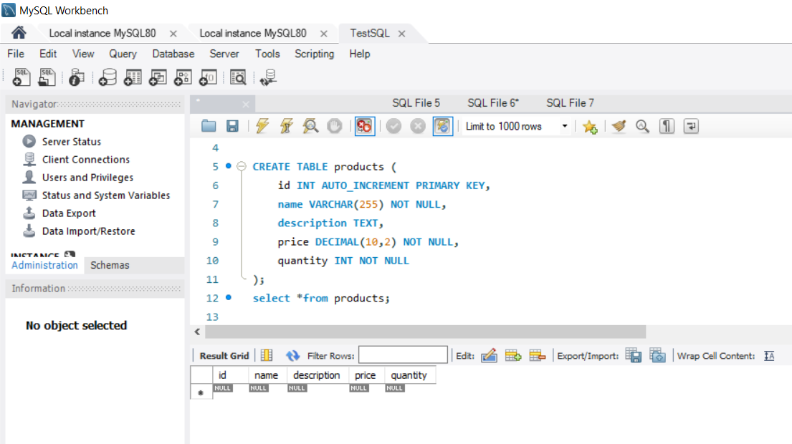

Insert Sample Data
INSERT INTO products (name, description, price, quantity) VALUES
('Laptop', 'Dell XPS 13', 1200.00, 10),
('Smartphone', 'Samsung Galaxy S21', 999.00, 20),
('Tablet', 'Apple iPad Pro', 799.00, 15);

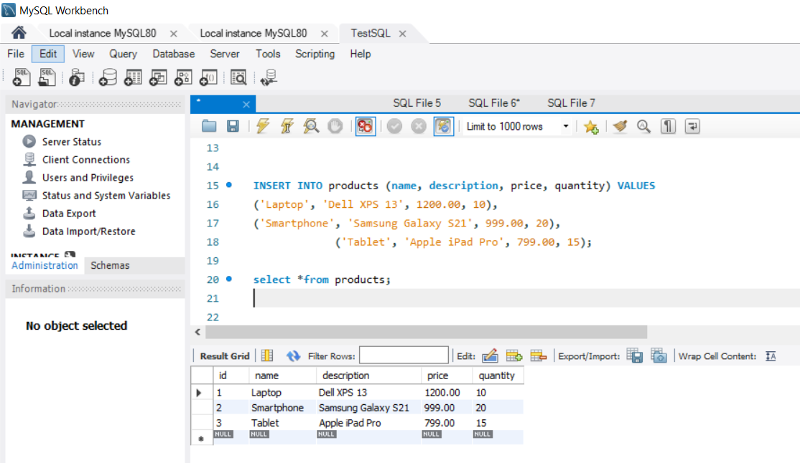

Execution : Run reactjs , spring boot and mysql at a time

Outputs:

From GUI(ReactJS)

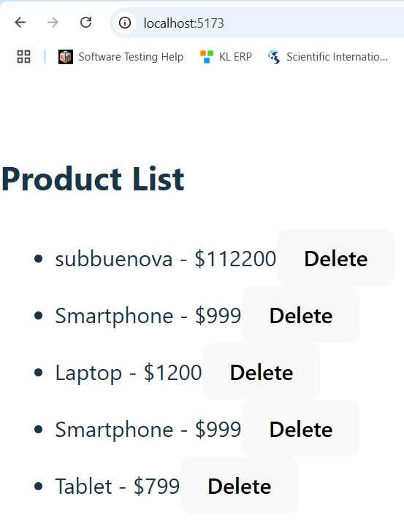

Add product:

http://localhost:5173/add

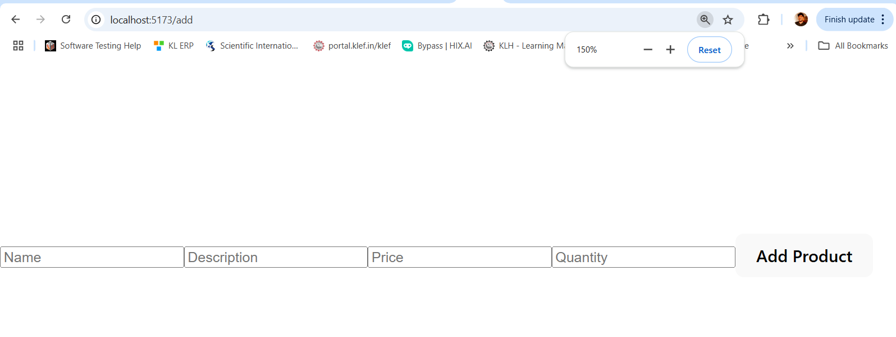

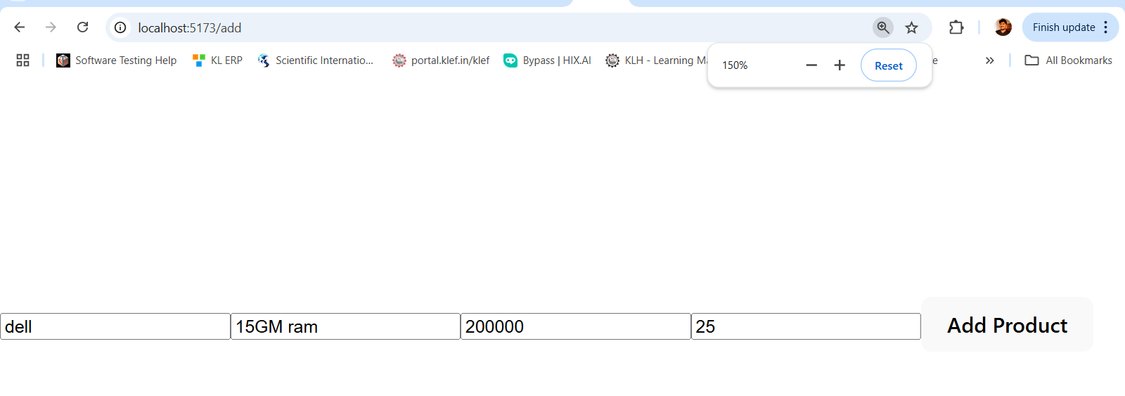

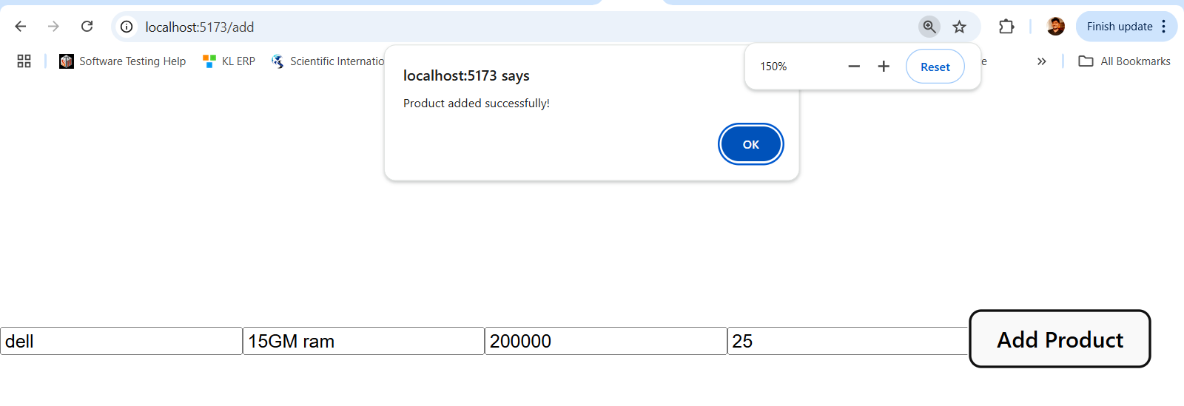

Now check database: this product added in database or not

Select *from products;

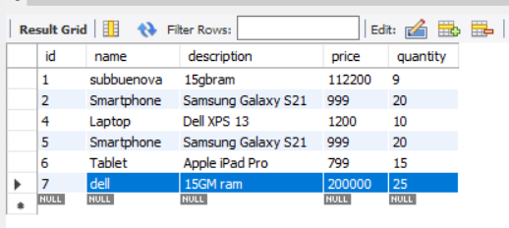

Now I want update row one:
http://localhost:5173/update/1
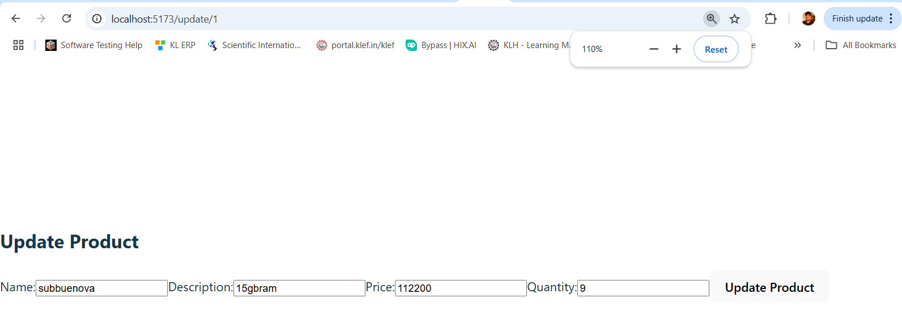

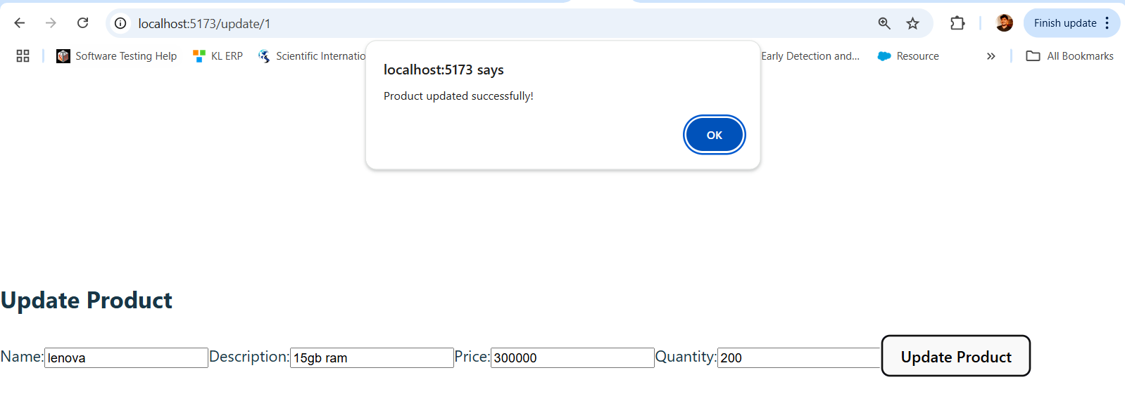

Now check database: first row updated or not

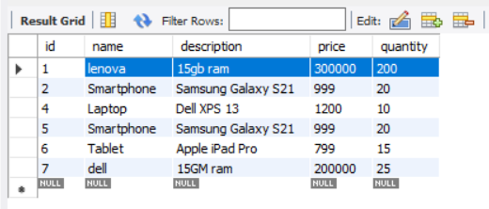

Delete product:now I want delete 5th row let see

http://localhost:5173/delete/5

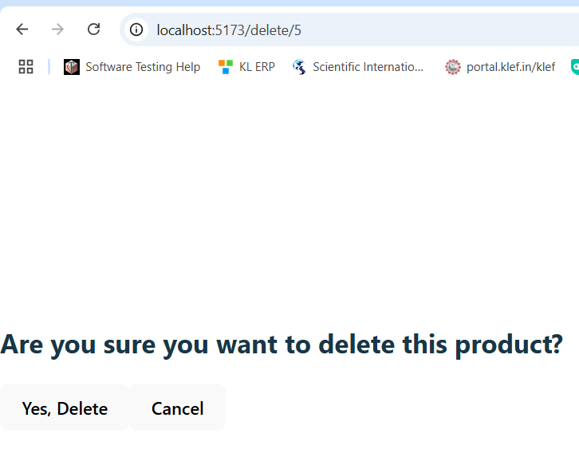

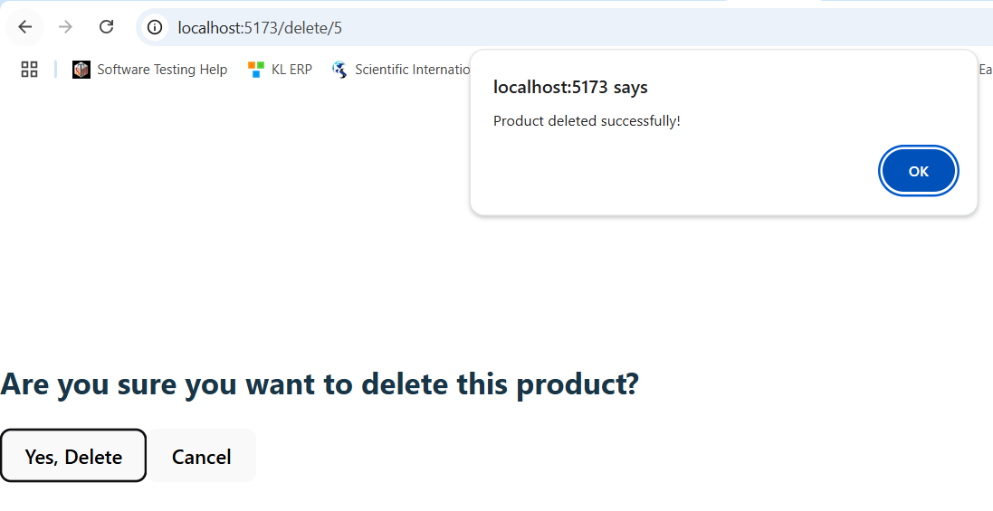

Now check database:product deleted or not

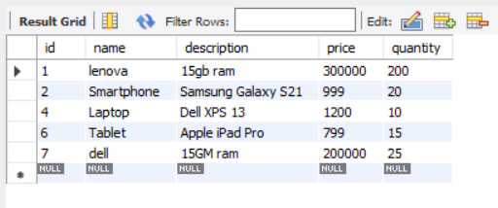

Results:
Thus, the integration with reactjs +SpringBoot +Mysql successfully executed successfully for adding product ,updated product and deleting product from GUI(frontend using reactJS) finally, Integrating ReactJS with Spring Boot and MySQL to perform CRUD (Create, Read, Update, Delete) operations involves setting up both the frontend and backend components to work seamlessly together.

NOTE:

You can add product, update product and delete product using postman also.
You guys better to do this one also and check database

Viva:
  - How does data flow between a ReactJS frontend and a Spring Boot backend in a full-stack application?
  - How do you configure CORS in a Spring Boot application to allow requests from a ReactJS frontend?
  - What is the role of JPA in a Spring Boot application, and how does it interact with a database?
  - How do you handle asynchronous operations in React when fetching data from the Spring Boot API?
  - Can you describe a typical CRUD operation cycle from the ReactJS frontend to the database via Spring Boot and JPA?

Solutions:
1. How does data flow between a ReactJS frontend and a Spring Boot backend in a full-stack application?
In a full-stack application, the ReactJS frontend acts as the client that sends HTTP requests to the Spring Boot backend, which serves as the server. When a user interacts with the React application, it may trigger actions that require data from the server, such as fetching product details or submitting a new product entry. To facilitate this, the React frontend utilizes HTTP methods like GET, POST, PUT, and DELETE to communicate with the backend's RESTful endpoints. The Spring Boot backend processes these requests, interacts with the database as needed, and returns appropriate responses, often in JSON format. This seamless exchange ensures that the frontend and backend work together to provide dynamic and responsive user experiences.
2. How do you configure CORS in a Spring Boot application to allow requests from a ReactJS frontend?
Cross-Origin Resource Sharing (CORS) is a security feature implemented by browsers to prevent unauthorized access to resources hosted on different domains. In a typical development setup, the ReactJS frontend and Spring Boot backend run on different ports (e.g., React on port 3000 and Spring Boot on port 8080), leading to CORS issues. To resolve this, you can configure CORS in your Spring Boot application by using the @CrossOrigin annotation on your controller classes or methods. This annotation allows you to specify which origins are permitted to access the resources. For example, adding @CrossOrigin(origins = "http://localhost:3000") to a controller allows requests from the React development server. Alternatively, you can define global CORS configurations in your application's security settings to apply the rules universally.

3. What is the role of JPA in a Spring Boot application, and how does it interact with a database?
Java Persistence API (JPA) is a specification that provides a standard for object-relational mapping (ORM) in Java applications. In a Spring Boot application, JPA simplifies database interactions by allowing developers to work with Java objects rather than SQL queries. Spring Data JPA, an extension of JPA, provides repositories that handle CRUD operations automatically. By annotating your domain models with JPA annotations like @Entity, @Id, and @GeneratedValue, Spring Boot recognizes these classes as entities that correspond to database tables. The repository interfaces, typically extending JpaRepository, offer methods to perform database operations without the need for boilerplate code. This abstraction streamlines database interactions and enhances productivity.
4. How do you handle asynchronous operations in React when fetching data from the Spring Boot API?
In React, asynchronous operations are essential for fetching data from APIs without blocking the main thread, ensuring a smooth user experience. To handle these operations, React developers commonly use the fetch API or libraries like Axios to make HTTP requests to the Spring Boot backend. These functions return promises, which can be handled using .then() for promise chaining or async/await syntax for a more synchronous-like flow. For instance, using async/await, you can define an asynchronous function that waits for the API response before proceeding, allowing you to manage loading states and handle responses or errors appropriately. This approach ensures that data fetching does not interfere with the responsiveness of the React application.
5. Can you describe a typical CRUD operation cycle from the ReactJS frontend to the database via Spring Boot and JPA?
A typical CRUD (Create, Read, Update, Delete) operation cycle in a full-stack application involves coordinated interactions between the ReactJS frontend, the Spring Boot backend, and the database. Here's an overview of each operation:
- Create: The React frontend collects user input through forms and sends a POST request to the Spring Boot backend with the new data. The backend processes this request, uses JPA to persist the data in the database, and returns a response indicating success or failure.
- Read: The React application sends a GET request to the backend to retrieve data. The Spring Boot controller handles this request, fetches the data from the database using JPA repositories, and returns it to the frontend, which updates the UI accordingly.
- Update: When a user modifies existing data, the React frontend sends a PUT or PATCH request to the backend with the updated information. The backend updates the corresponding database record using JPA and returns the updated data or a success message.
- Delete: The React application sends a DELETE request to the backend to remove a specific record. The backend deletes the record from the database using JPA and confirms the deletion to the frontend.

